ASR 5452

1. Report: Outstanding Outbound HU for Loading - Add report criteria - ship to
2. Upload Shipment HU – Add retrieve criteria HU and Ship-to

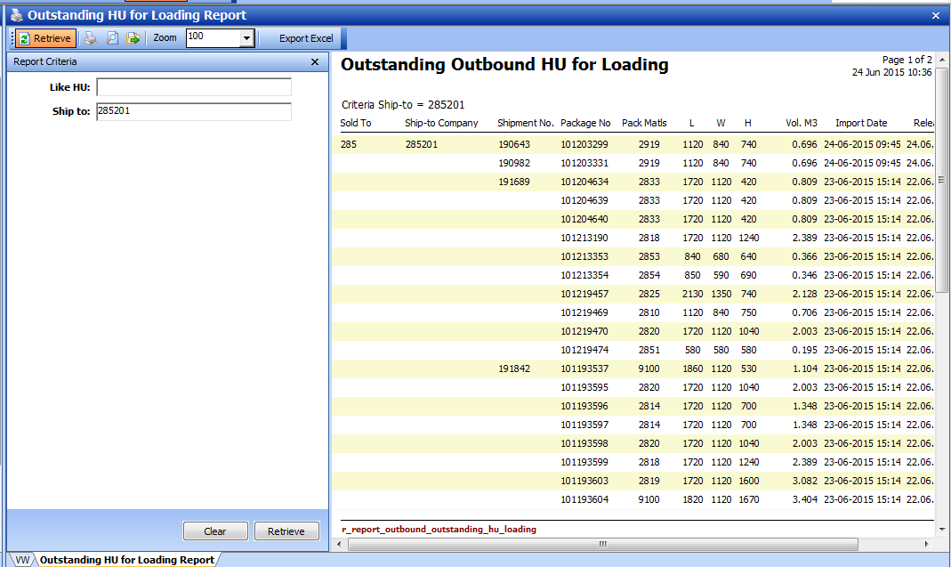

285201

